Roll #: ________ Quiz-3 (A & B): CS-3001: Computer Networks (Nov. 01, 2022)

Name: _____________ Section: _____ Time: 20 minutes Marks: 10

Consider the following plot of TCP window size as a function of time for two TCP connections A and B. In this problem, we will suppose that both TCP senders are sending large files. We also assume that the packet loss events are independent in connection A and B.
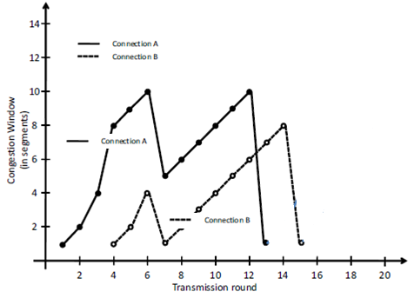
a) Considering the above values of congestion window (cwnd) for these connections, can we identify the type of TCP connections (Reno or Tahoe) that have been used by connection A and B? Justify your answers. [2 Marks]
b) How the value of Threshold parameter varies between the 1st and the 14th transmission rounds for each connection? [2 Marks]
c) At the 12th transmission round for connection A, is segment loss detected by a triple duplicate ACK or by timeout? Justify your answer. [1 Mark]
d) Draw (on the figure above) the cwnd values of both connections up to the 20th transmission round, considering that there is no further timeout or duplicate ACK situation for any of the connections. [2 Marks]
e) Consider your solution in part d; assume that the segment size is 1460 bytes and that a total of 87600 bytes have been successfully transmitted over connection A before the 13th transmission round. At which transmission round the cumulative amount of the successful transmitted data is equal to 163520 bytes? Again we assume that there is neither timeout nor duplicate ACK after the 13th transmission round. [3 Marks]

